REPEAT ON ERROR

Using the **Repeat on Error** group, you can repeat a series of activities when an unmanageable error occurs. The activities in this group are executed once. If there are no unmanageable errors, the loop terminates. If an error occurs for which there is no error transition, the condition of the loop is evaluated. If the condition is true, the loop terminates. If the condition is false, the loop repeats until there is no error or the condition is true.

**Scenario:** im retrying the process while giving port number wrong in jdbc connections.

Take activities as below in Tibco bw6.x studio.

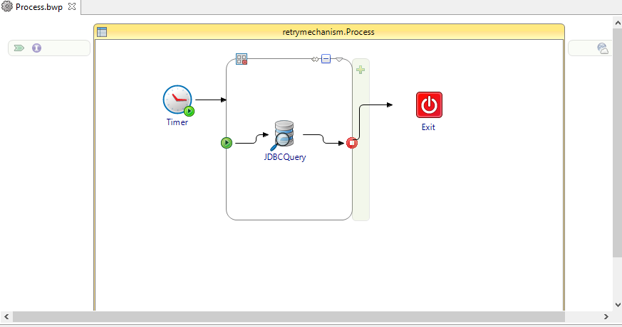

I Mentioned wrong jdbc port number like 5312 actual port number is 5432.

So we need to repeat on error until given index number value.

Mentioned repeat on error index value 4 so the loop will be iterate 4 times on the error next terminate the loop.

The loop values mentioned as below.

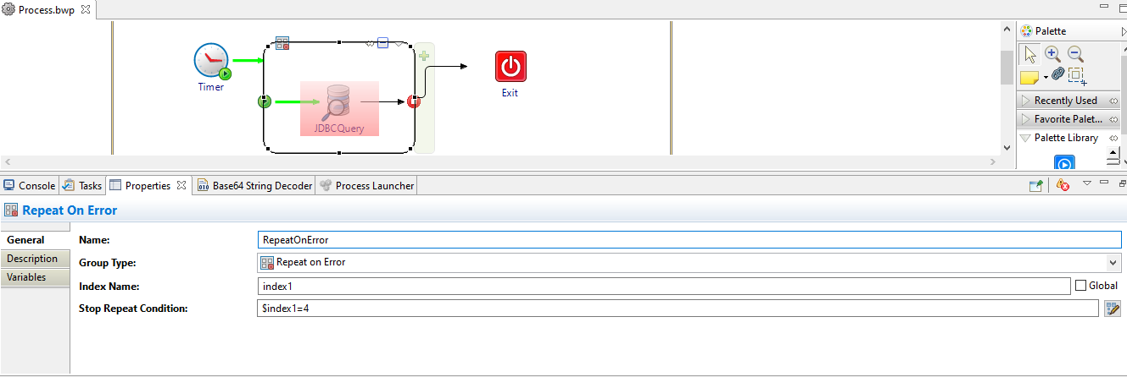

After the debugging the loop will be run as below.

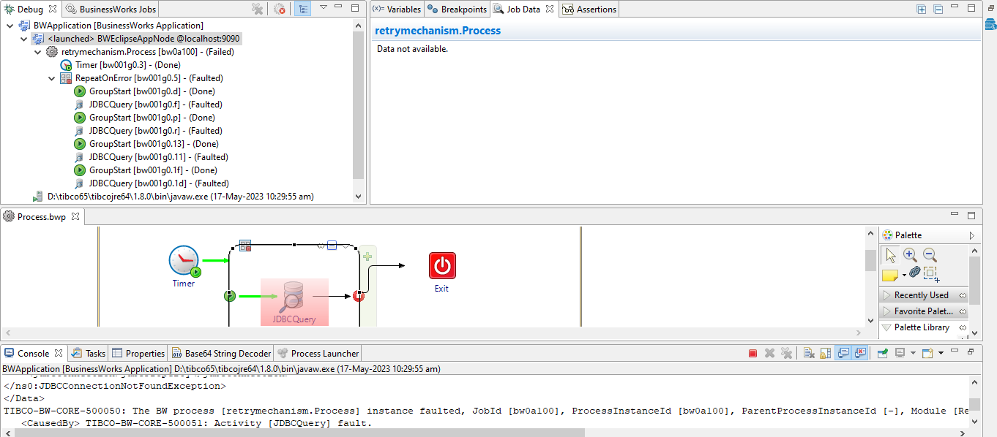

The loop executed 4 times and terminated after completing index value.

Note:-

If condition is true the loop will be terminate after condition satisfied